The purpose of this one-day workshop is to introduce new as well as aspiring department chairs in AITU schools to important topics in managing and leading an academic department.
7:30 a.m. Continental Breakfast
8:00 Welcome and Introductions
Maria Vaz, Provost, Lawrence Technological University
8:10 Overview of the AITU
Jeremy Haefner, Provost and Senior Vice President,
Rochester Institute of Technology
8:30 The Culture of an AITU School
Maria Vaz
    - Professional Degrees,
    - Outward-looking perspective…Admissions, Advisory Boards, Corporate Relations, Alumni, Fundraising, etc.
    - Responsibility
9:00 Your Old Role vs. Your New Role
Bruce Bursten, Provost and Senior Vice President, Worcester Polytechnic Institute
    - A new network--working with fellow department chairs across your institution
    - Privacy of Information (Private vs. Public)
    - Collegiality…You now have to be the adult!
    - You now have to evaluate your former (and maybe future) peers
    - People will treat you differently
    - Diversity and gender issues at AITU schools—how they differ from other schools
    - Risk Management
9:45 Coffee Break
10:00 The Difference Between Management and Leadership—
and Why Both are Essential
Frances Bronet, Provost and Senior Vice President, Illinois Institute of Technology
    - Getting the day-to-day done
    - Where are we headed and how will we get there?
10:40 Revenue Generation and Management
Provosts Bronet, Bursten, Haefner, Vaz
    - How Budgets work
    - Enrollments in current offerings
    - New programs
    - Research
    - The focus on the private sector
11:40 Taking Care of You
Provosts Bronet, Bursten, Haefner, Vaz
12:00 Noon Lunch
1:00 p.m. Case Studies
The afternoon portion of the workshop will be devoted to case studies submitted by the participants in advance of the workshop.
2:15 Coffee Break
2:30 Difficult Conversations-- A role playing exercise.
Jeremy Haefner
Performance Evaluations, Fundraising, Sexual Harassment, etc. and other difficult conversations you will have as a department chair.
3:15 Case Studies, continued
4:30 General Discussion/Feedback
5:00 Adjournment

There is a reception the evening of the workshop that is the reception for all attendees at the Academic Chairpersons Conference.
2017 Academic Chairpersons Conference
February 8-10, 2017
InterContinental New Orleans,
444 St. Charles Avenue, New Orleans, LA

http://conferences.k-state.edu/academicchairpersons/

Speaker Profiles

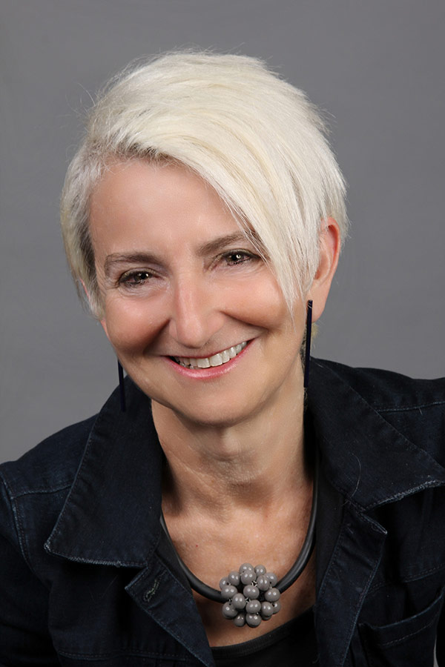
Frances Bronet
Senior Vice President and Provost
Illinois Institute of Technology

Previously, Provost Bronet served as acting provost at the University of Oregon where she was also Distinguished Professor, Association of Collegiate Schools of Architecture, and a professor of architecture. She also served as dean of the School of Architecture and Allied Arts at Oregon since 2005.
Bronet holds degrees in architecture and engineering from McGill University. She was licensed by the Ordre des Architectes du Quebec in 1982, practicing in multiple offices, including her own, in Montreal. She received a Master of Science degree in architectural design from Columbia University. Prior to coming to Oregon, Bronet was a professor and former associate as well as acting dean of architecture at Rensselaer Polytechnic Institute (RPI) while continuing design consulting in New York.
She has been developing and publishing work on multidisciplinary design curricula connecting architecture; engineering; science, technology and society (H&SS); dance; and electronic arts for the past 20+ years. She has received extensive funding from NSF, NEA and NEH/FIPSE for work on new pedagogical models using design for technical and/or interdisciplinary learning.
Selected publications include: “Quilting Space: Alternative Models for Architectural and Construction Practice,” in Research in Science and Technology Studies: Gender and Work; “Space-in-the-Making,” in Geographies of Dance; “Teaching the Design: Feminist Practice,” with Linda Layne, anthropologist, in Feminist Technologies; “Product Design and Innovation: The Evolution of an Interdisciplinary Design Curriculum,” International Journal for Engineering Education (w/Gabriele, et al).
Bronet has been named an Association of Collegiate Schools of Architecture (ACSA) Distinguished Professor, a Design Intelligence Most Admired Educator (2011 & 2014), and is the co-founder of the ACSA Women’s Leadership Council. She recently co-chaired the ACSA New Administrators’ Conference. Bronet will serve as ACSA Vice Chancellor for the College of Distinguished Professors in 2015 and as Chancellor in 2016. She is a recipient of the 2001 Carnegie Foundation for the Advancement of Teaching New York Professor of the Year and the 2001 William H. Wiley Distinguished Professor Award for excellence in teaching, research, service and contributions to the university and community.

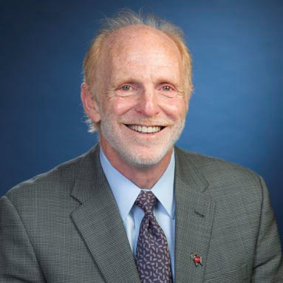
Bruce Bursten
Provost
Worcester Polytechnic Institute

Bruce Bursten was born in Chicago and raised in Milwaukee. He received his SB in chemistry with honors from the University of Chicago in 1974, and his PhD in chemistry from the University of Wisconsin-Madison in 1978 under the direction of the late Professor Richard F. Fenske. He was a National Science Foundation postdoctoral fellow at Texas A&M University from 1978 to 1980, conducting research with the late Professor F. Albert Cotton. He joined the faculty of The Ohio State University in 1980 as an assistant professor of chemistry; in 1997 he was named Distinguished University Professor. In October 1999 he became chair of the Department of Chemistry at Ohio State, a position he held until October 2003. In 2005 he moved to the University of Tennessee, Knoxville as Distinguished Professor of Chemistry and dean of the College of Arts and Sciences, a position he held until the end of 2010. In 2006 he was elected to the presidential succession of the American Chemical Society, and served as president-elect for 2007, president for 2008, and immediate past president for 2009. During those three years, he also served as a member of the ACS Board of Directors. From January 2011 to July 2012 he was a visiting professor in the departments of Chemistry at Columbia University and Barnard College. In 2014 he was elected to leadership of the Section on Chemistry of the American Association for the Advancement of Science (AAAS) and served as chair-elect in 2014; he is now chair, and will serve as retiring chair in 2016. In June 2015 he moved to Worcester Polytechnic Institute in Worcester, Mass., as provost and senior vice president, and professor of chemistry and biochemistry. Bursten conducts research in inorganic chemistry. His research centers on the correlation of theoretical and experimental electronic structural data with the bonding and reactivity patterns of metal-containing molecules. He is the author or coauthor of more than 160 research papers, and he has presented more than 200 research seminars at other universities, national laboratories, and companies. He is also a coauthor of one of the leading textbooks in college general chemistry, currently in its 13th edition. He has received numerous national and international honors for his academic accomplishments. Among these, in 1984 he received a Camille and Henry Dreyfus Foundation Teacher-Scholar Award and in 1985 he was named a fellow of the Alfred P. Sloan Foundation. At Ohio State, he received the University’s Alumni Award for Distinguished Teaching in 1982 and 1996, the Distinguished Scholar Award in 1993, and the Faculty Award for Distinguished University Service in 2002. In 2001 he received the Catalyst Award from the American Chemistry Council, a national award for teaching of chemistry. He received the 2003 Spiers Medal and Prize from the Royal Society of Chemistry in the United Kingdom, he was elected a fellow of the AAAS in 2004, and he received the Morley Medal of the Cleveland Section of the ACS in 2005. He was elected a fellow of the American Chemical Society in 2010.

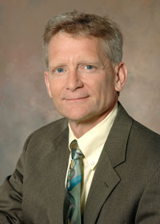
Jeremy Haefner
Senior Vice President for Academic Affairs and Provost, Rochester Institute of Technology

Dr. Haefner was appointed Senior Vice President for Academic Affairs and Provost at RIT in 2008.
Before joining RIT, Dr. Haefner served in a number of administrative roles at the University of Colorado at Colorado Springs including concurrent appointments as vice chancellor for research and innovation, dean of the Graduate School, Dean of the College of Engineering and Applied Science, director of the Colorado Institute for Technology Transfer and Implementation. He also was chair of the mathematics department, director of the campus-wide Teaching and Learning Center, faculty associate for information technology and faculty associate for teaching and learning, and professor of mathematics at UCCS.
He joined the faculty at the University of Colorado in 1989 after spending three years at the University of Tennessee Knoxville.
Throughout his administrative career, Dr Haefner has exemplified a commitment to research, community service and learner-centric pedagogies. He maintains a passion for innovation and creativity along with a desire to effect positive change.
Dr. Haefners research expertise includes the mathematics of integral representation, module and matrix theory; he has published widely and has been externally supported by a number of funding agencies. Dr. Haefner has been recognized with a National Security Agency Young Investigator Award, a research fellowship from the Universidad de Murcia in Spain, and numerous research contracts with the National Security Agency, the University of Colorado and the University of Tennessee. Dr. Haefner was principal investigator for a $4.6 million grant from the Air Force Office of Sponsored Research that supports homeland security and space education, as well as the principal investigator for a $2.7 million grant from the Air Force Office of Sponsored Research supporting science and engineering education to build the next generation of engineers and scientists.
Dr. Haefner maintains a strong interest in active learning and technology-enhanced instruction as learner-centric pedagogies. He developed the program in Applications in Technology for Mathematics Education in 1995, which provides technology training to students interested in careers in mathematics education. He also has co-developed the MathOnline program and the system-wide CU Online Tutoring program, which provides university-level mathematics courses and tutoring over the internet to high school students across the State of Colorado. In 1998, Dr. Haefner won the inaugural Innovations in Teaching with Technology award from the University of Colorado at Colorado Springs and the inaugural University of Colorado President's Faculty Excellence Award for Advancing Teaching and Learning through Technology. The CU System has recognized him for his collaborative contributions to using technology in education.
Dr. Haefner was an American Council on Education Fellow in 2006-2007 and spent his fellowship year under the mentorship of President John C. Cavanaugh at the University of West Florida.
Dr. Haefner enjoys gaming with his family and is an active competitor in sprint triathlons.

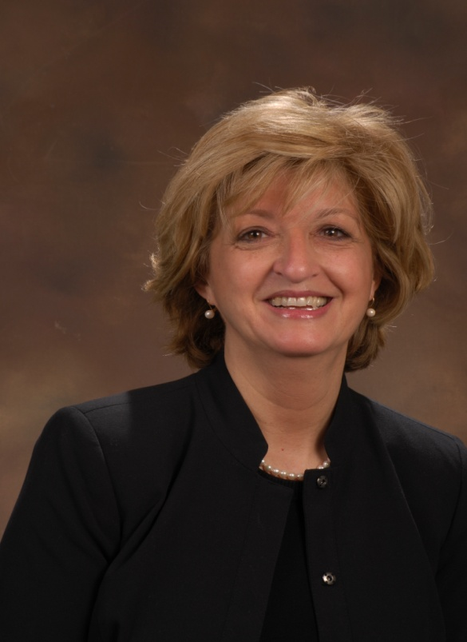
Maria J. Vaz

Provost, Lawrence Technological University
Dr. Maria Vaz received her undergraduate degree in physics in 1976 from the University of Lisbon, Portugal. In 1978 she received her masters degree and in 1981 she received her Ph.D. in Physics from Kent State University.
Dr. Maria Vaz started her career at Lawrence Technological University in 1984 as an Assistant Professor of Physics. In 1988 she was promoted to Associate Professor of Physics and in 1993 she was promoted to Professor of Physics.

During her career at Lawrence Tech, Dr. Vaz has been the Department Chair of the Natural Sciences Department (Physics and Chemistry) (1992-1994), the Associate Dean of the College of Arts and Sciences (1994-1998) and Associate Provost and Dean of Graduate Programs (1998-2006). She also served as Interim Dean of the College of Arts & Sciences (2004-2005) and Interim Dean of the College of Engineering (2005-2006). On February 1, 2006 she was named Interim Provost at LTU and on July 1, 2006 Dr. Vaz became the Provost at LTU.

Dr. Vaz is responsible for all academic affairs of the university including the academic colleges, enrollment management, and academic and student support services. She works closely with the president and vice-presidents to accomplish the goals of the university.
Dr. Vaz has worked in science and engineering education and assessment of student learning. She received numerous grants from the U. S. MDE, NEH/Fipse and private foundations to improve science education in the schools including the development of an innovative masters program for science teachers. In addition, Dr. Vaz has also been the PI of several grants through the Kern Family Foundation to transform engineering education with the goal of graduating engineers with an entrepreneurial mindset.

Because the workshop directly precedes the Academic Chairpersons Conference, topics that are germane to all department chairs, independent of regulatory status or focus (publicly controlled vs. private-nonprofit, general vs. historical science and technology emphasis) are given greater emphasis in that complementary meeting.

